CARGO MANAGEMENT SYSTEM
ABSTRACT

The project entitled as “CARGO MANAGEMENT SYSTEM” is a supply chain
management component that is used to meet customer demands through planning, control
and implementation of the effective movement and storage of related information, goods and
services from origin to destination. Cargos service providers face many problems when they
do work manually. Some of the drawbacks are customer services become inefficient,
transportation cost may increase. Hence, cargo management system application solves all
the entire problem and provides many features like, warehouse management, fleet
management, processing orders, inventory control and order tracking.
The project contains two type of interaction like Admin and Customer. Admin has
authority to add or remove goods in the system and also maintain records of the goods
available in the warehouse. The admin will update the goods details if required. Whereas the
customer can book the cargo by entering source and destination place.
The main advantages of the system are it excludes the use of paper work by managing
all the records electronically. The administrator need not keep a manual track of the goods
and can keep updating the system by filling in the details of the new goods arrived in
warehouses and their availability. Hence it saves the human efforts and resources.

SYSTEM SPECIFICATION
HARDWARE SPECFICATION:
- Processor : P 4 700 GHz.
- RAM : 4 GB RAM
- Hard Disk Drive : 180 GB

SOFTWARE SPECIFICATION
- Operating System : Windows 7/8/10
- Front End : JAVA
- Back End : SQL

EXISTING SYSTEM
In existing system there will be order form (or) letter which is registered or updated by the employee of an Organization. The customer has to visit the office whenever they have any booking regarding the services, which is time consuming process. The registered booking may be forwarded to the workers in the specified department.

Drawbacks of Existing System

The following are the drawbacks of the existing system

    - In Cargo management system, the process is done manually.

    - Due to that they face problems like data loss.

    - It consumes more time to process the bookings.

    - The customer does not know current location of the product.

PROPOSED SYSTEM
Previously, In Cargo Management system they were done manual. Now developed the site to make the things computerized. The customer can submit the orders through the website. The submitted orders are assigned to the workers for further action. The orders can be tracked by the users. The system is a web enabled centralized information and management application to meet customer requirements in building best relations with its public community by providing fast mechanism to the customer grievances. The website will collect more information from the user and give a better view to the booking of cargoes.

After made booking it will be stored in the database. The user can view the booking of cargo in their Account and also able to track the live location of the cargo. The customer can also view the past booking in the website. The status of order is sent periodically through E-Mail.

Advantages of Proposed System

The following are the advantage of proposed system

    - Data is maintained in a structured format.

    - Reliable Customer Order Process.

    - User can view the location of orders.

MODULES
- Admin Login
This module is an managing the software, admin having an responsibility to perform the software. Here only one user can be using this application. We can refer the admin table and validating the username and password and perform into the login
- Customer Registration
This module collects all the information about the customer like name, mobile number and address details etc.… these details has been stored into the customer details. When we need to collect the customer details can get here.
- Ship Registration
Admin register the shipping details and register the ship, once ship has been registered can make an order under the ship. This is an main module for this software. Which contains shipping details also
- Order Registration
After the customer registration admin can able to register an order, this will collect all the information about the order details. Which collect the order product name, branch, from, to and weight also.
- Order Details
This module shown the order details in this order details tab. We can see the order current status as well, also able to display the amount of the order.

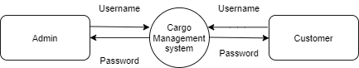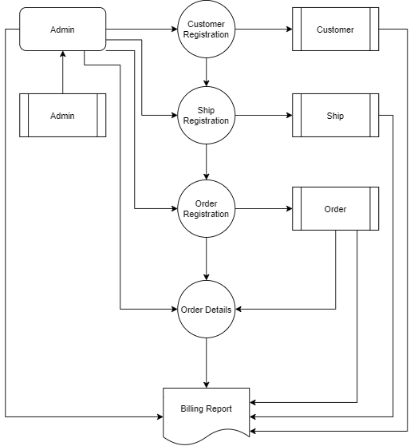

TABLE STRUCTURE
TABLE NAME: ADMIN
PRIMARY_KEY: admin id

FIELD NAME | FIELD TYPE | SIZE | CONSTRAINT
admin_id | Int | 10 | Primary key
Name | Varchar | 25 | Not null
Email | Varchar | 25 | Not null
Phone | Int | 10 | Not null
Address | Varchar | 25 | Not null
Zip_code | Int | 6 | Not null
Username | Varchar | 25 | Not null
Password | Varchar | 12 | Not null

TABLE NAME: SHIP
PRIMARY_KEY: ship id

FIELD NAME | FIELD TYPE | SIZE | CONSTRAINT
Ship Id | Int | 10 | Primary key
Vehicle_number | Varchar | 12 | Not null
Vehicle_type | Varchar | 15 | Not null
Vehicle_model | Varchar | 15 | Not null

TABLE NAME: ORDER
PRIMARY_KEY: order id
FOREIGN KEY: customer id

FIELD NAME | FIELD TYPE | SIZE | CONSTRAINT
Order id | Int | 10 | Primary key
Name | Varchar | 20 | Not null
Address | Varchar | 25 | Not null
Pickupdate | Date | 10 | Not null
Deliverydate | Date | 10 | Not null
Weight | Number | 25 | Not null
Packing_type | Varchar | 25 | Not null
Company_name | Varchar | 20 | Not null
Company_address | Varchar | 25 | Not null
Mobile_number | Number | 12 | Not null
Picklocation | Varchar | 15 | Not null
Droplocation | Varchar | 15 | Not null
Customer_id | Int | 10 | Foreign key

TABLE NAME: CUSTOMER
PRIMARY_KEY: customer id

FIELD NAME | FIELD TYPE | SIZE | CONSTRAINT
Customer id | Int | 10 | Primary key
Name | Varchar | 25 | Not null
Email | Varchar | 25 | Not null
Phone | Int | 10 | Not null
Address | Varchar | 25 | Not null
Zip_code | Int | 6 | Not null

